Guide for Jupyter Notebooks (PC):

Building a notebook in dropbox:

1. Install Anaconda
2. Open Anaconda
3. Click on “Environments” -> “r-tutorial”-> “Open with Jupyter Notebooks”

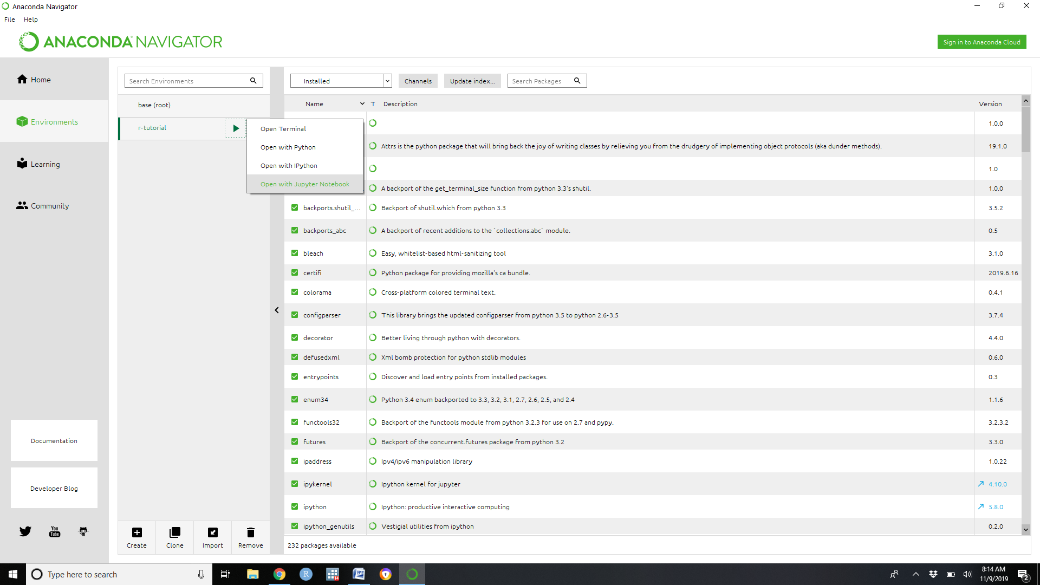

A command window will open and bring you to a list of folders.

1. Select “Dropbox” and navigate to the folder you are storing your materials in.

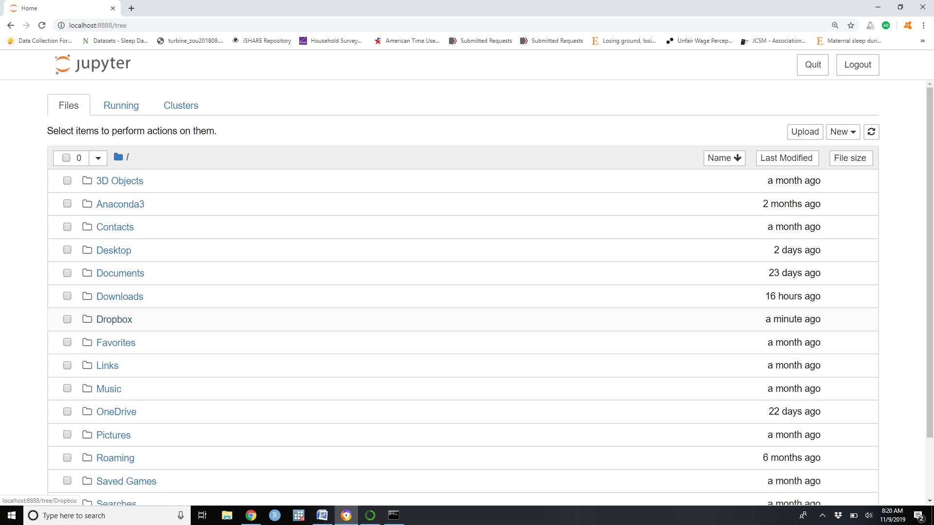

1. Once in the folder you are working in, click on “New ”(upper right) and select “R”: This will open a new R Jupyter Notebook that will be available in the shared dropbox folder allowing group edits.

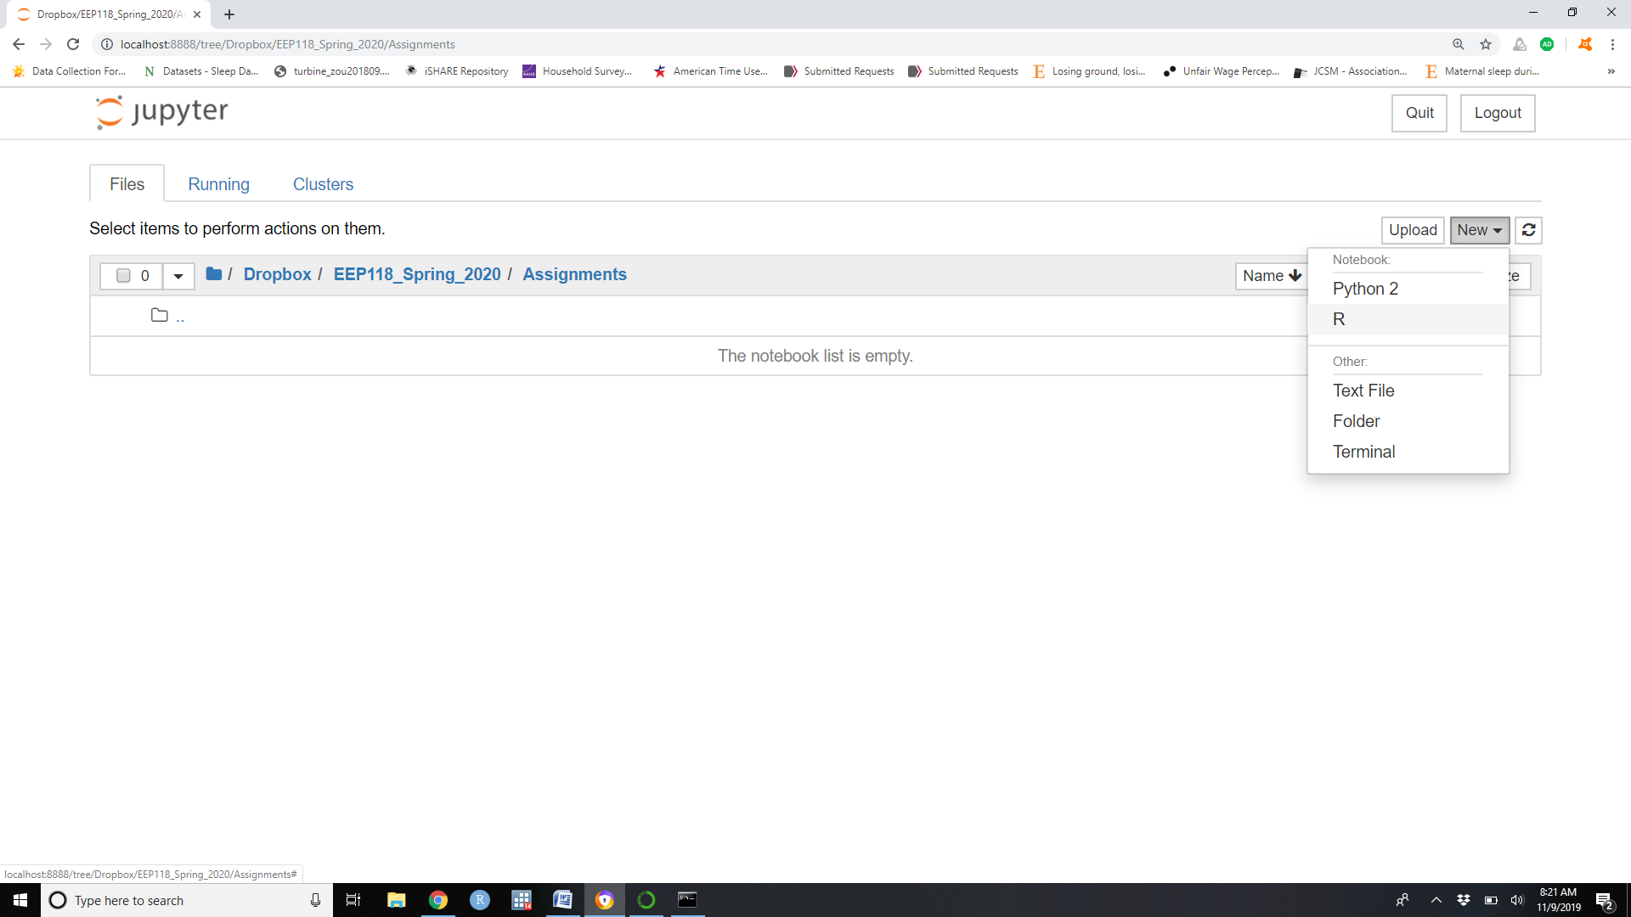

Basics of Editing a Jupyter Notebook:

1. You can rename your notebook by simply clicking on the name at the top of the page.
2. You can change a cell from code to markdown using the dropdown menu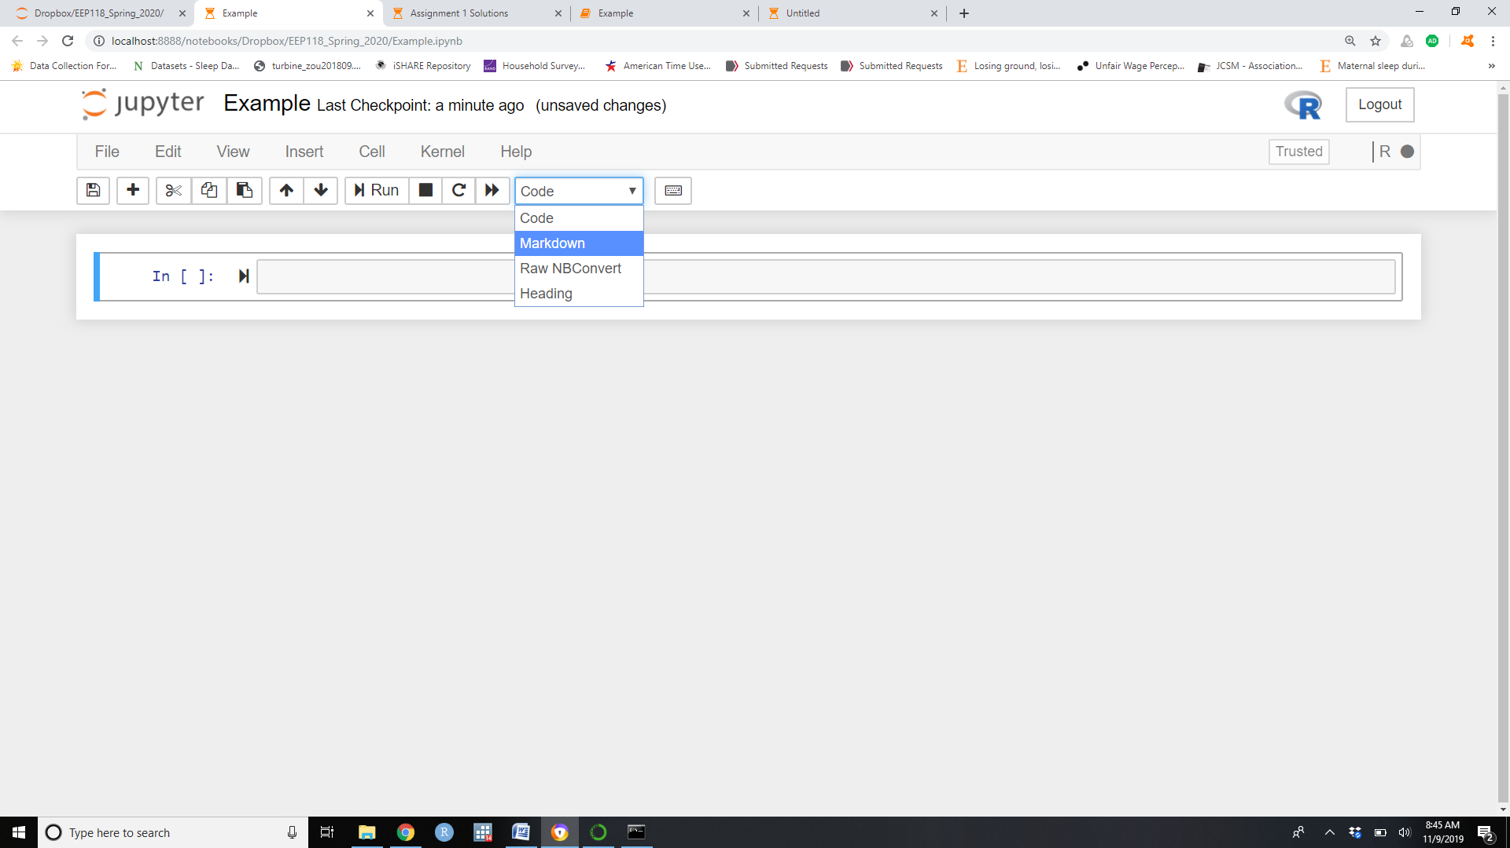
3. # controls the size of the font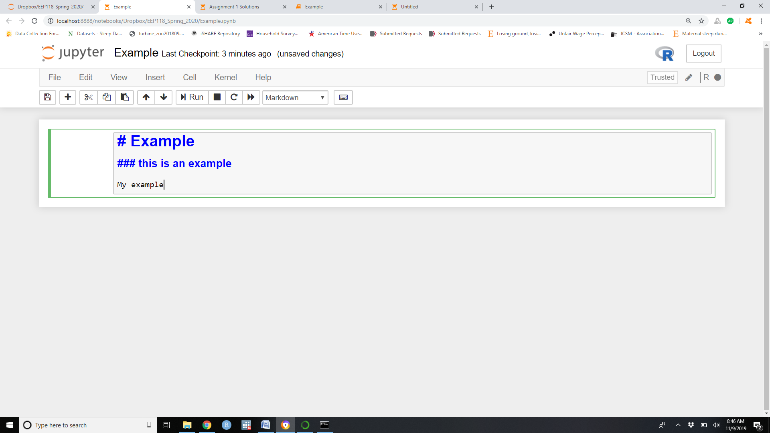
4. To run a cell (markdown or code cell) press ctrl+Enter and formatted cell will appear
5. Add a new cell by clicking the + button (top left)

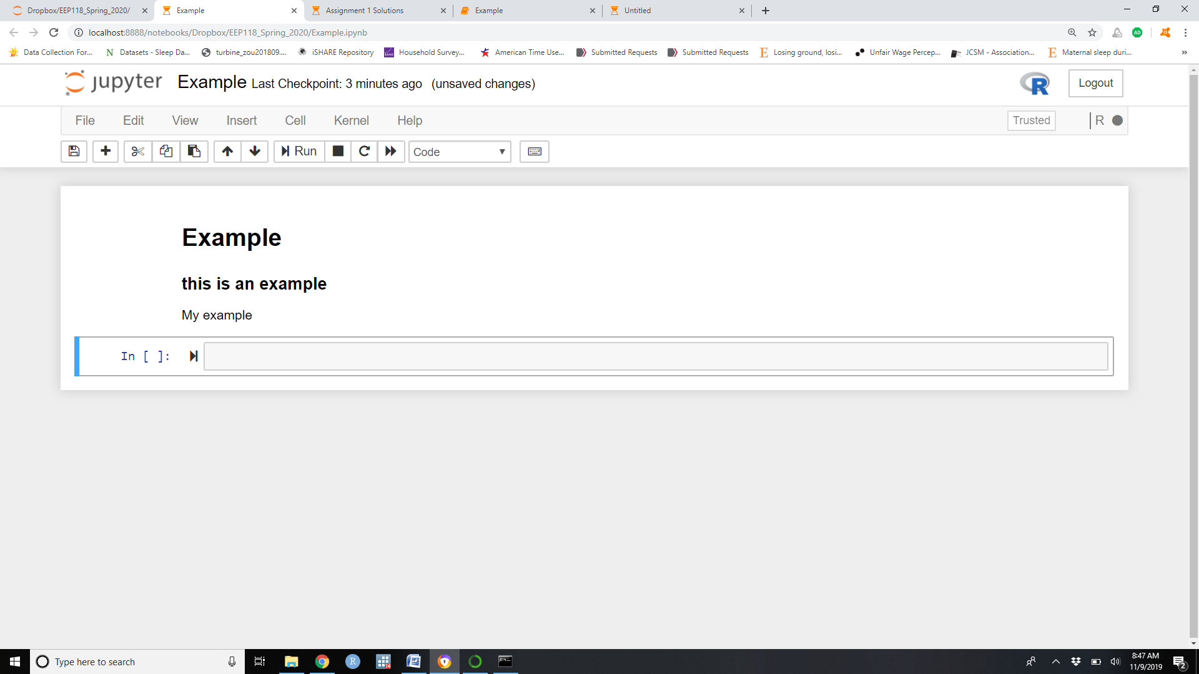

1. Type R code in the code cell.

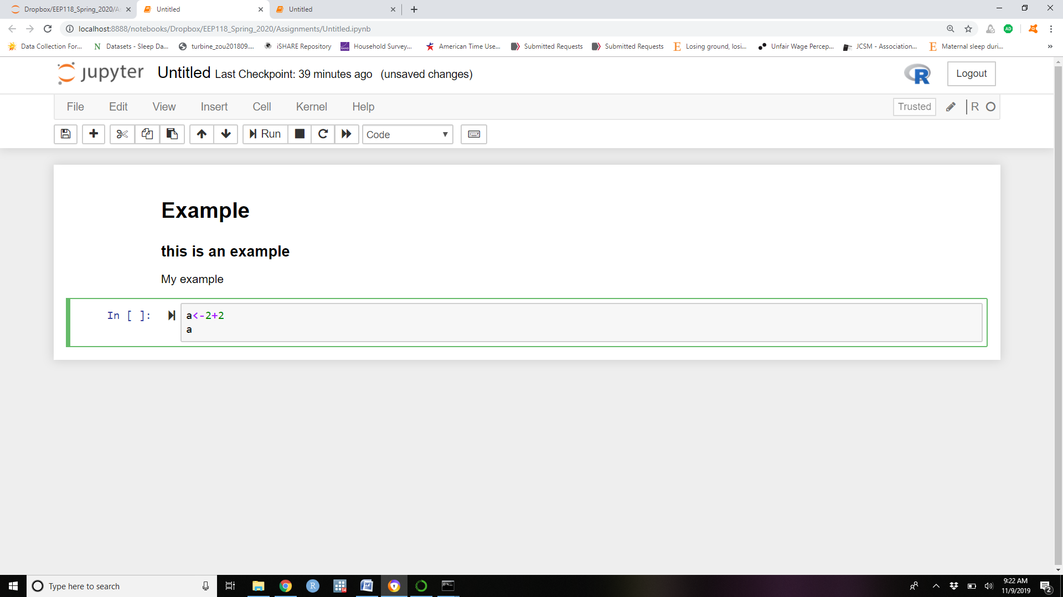

1. Press ctrl+enter to run the coding cell when it is highlighted

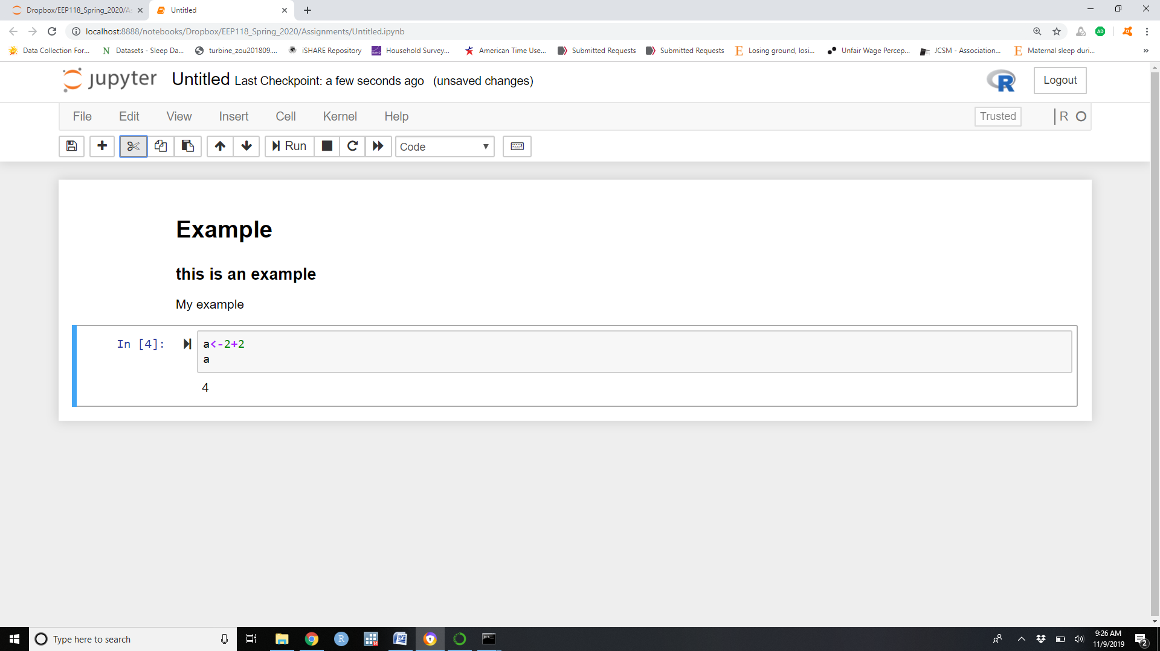

1. Place a dataset in the dropbox file with your notebook to be able to call the dataset in the notebook

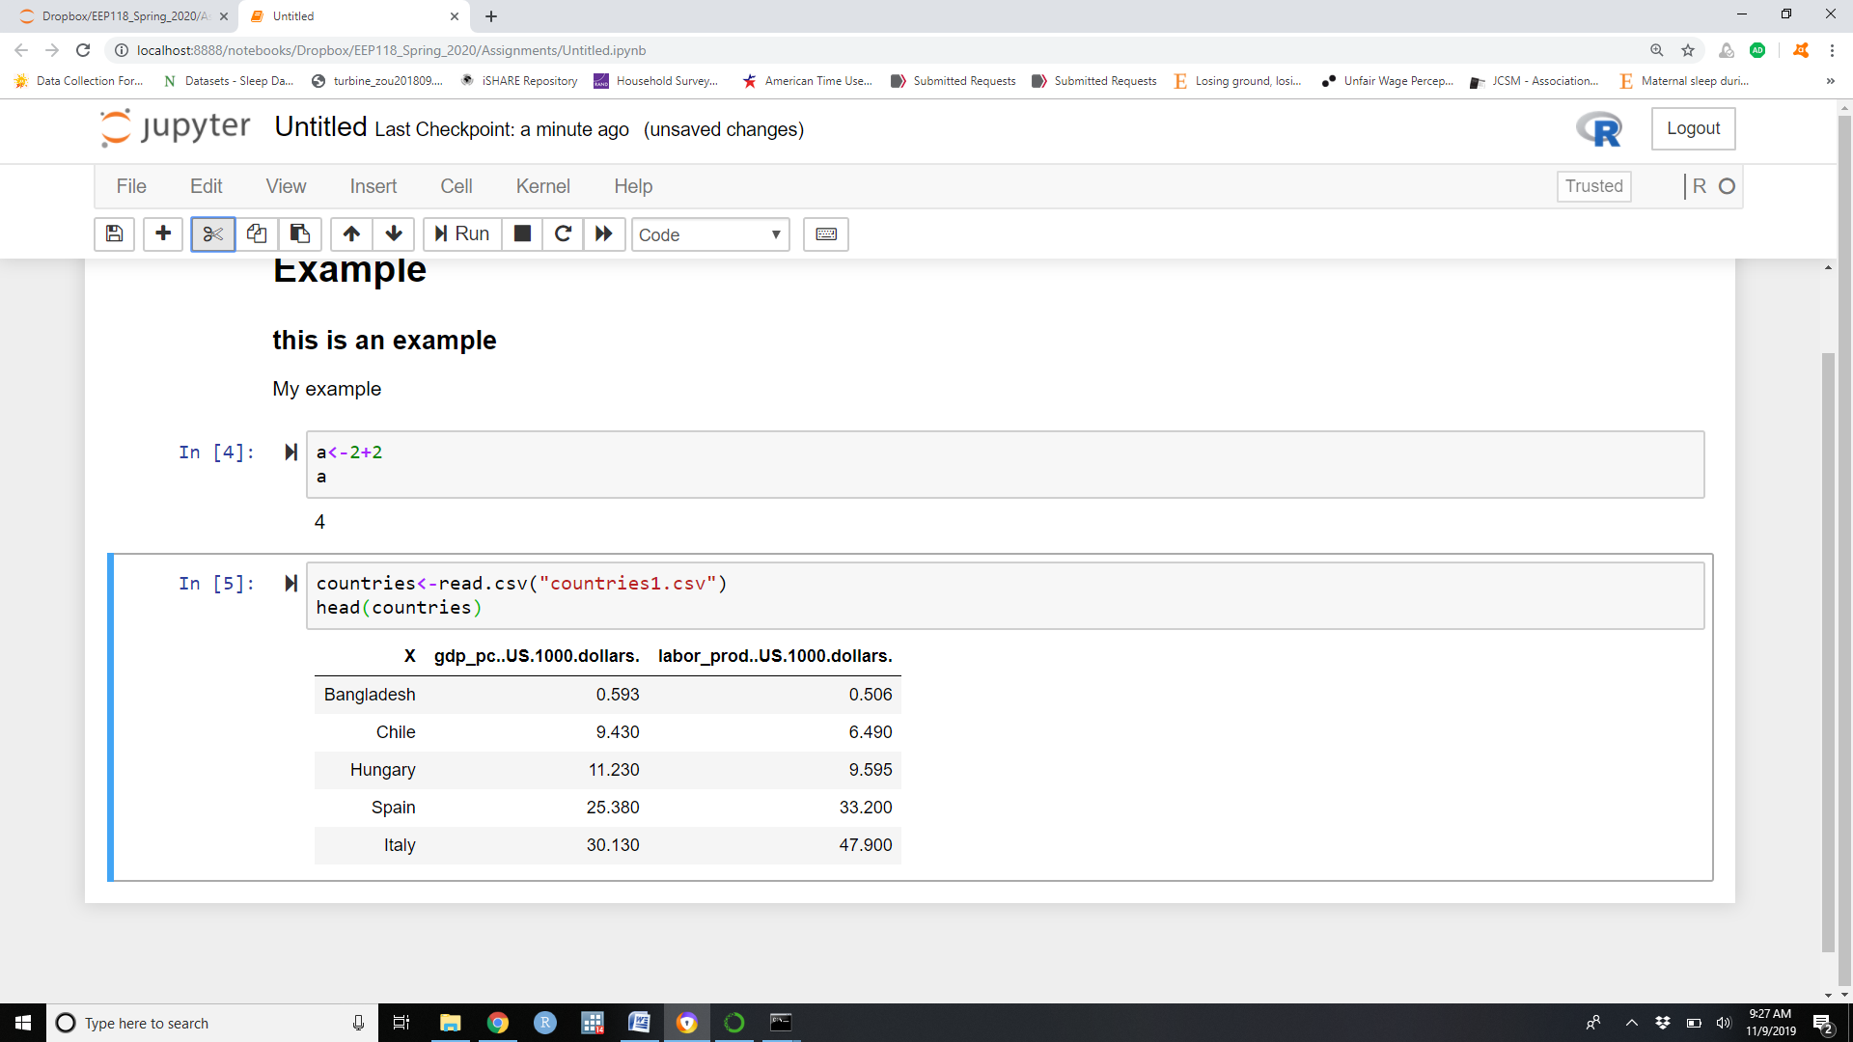

1. If your R code is part of a package, you need to call the package in your Jupyter Notebook code. For the students to have access to the package you need to make sure the package is loaded on the server (contact Eric to make sure the package is loaded on the server).

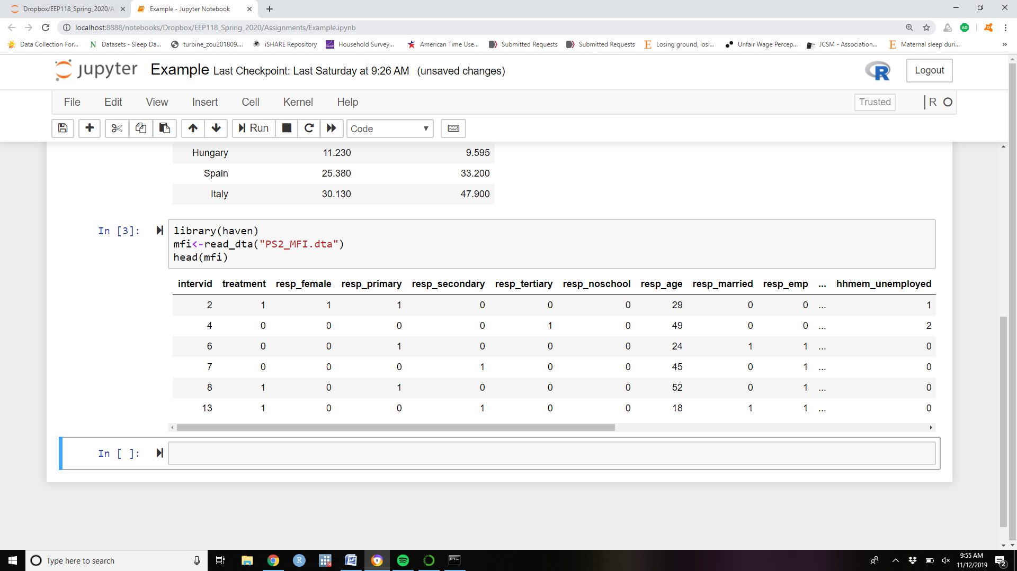

Other notes on editing your notebook:

-Math notation that works in LaTeX will work in markdown

-Once run, the code output will remain visible in the notebook even if you remove the code. When making an assignment make the assignment version (with blank cells for the students to complete) and a separate solutions version with coded solutions.

Making a notebook available to students:

Once the notebook is finalized in the dropbox folder, the notebook needs to be made available to students. This requires several steps:

-loading the notebook and needed data files to github

-create a hyperlink that will direct the student to the workbook

-make the link available to the students.

Loading the notebook and needed data files to github:

1. Navigate to the courses github site: <https://github.com/ds-modules/ENVECON-118>
2. Click on “Upload files” button (above files on the right)

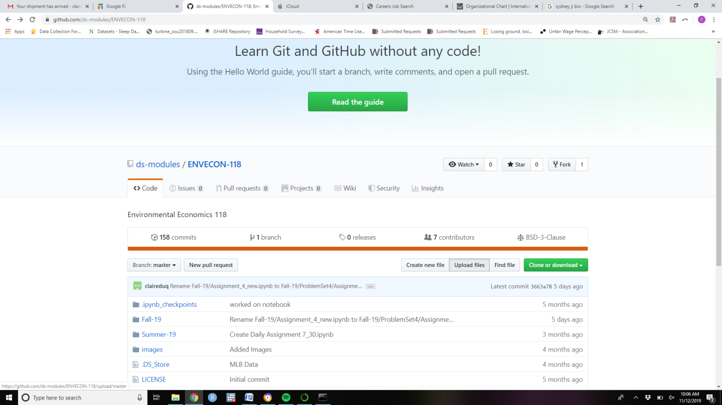

1. Drag the file from the dropbox folder into the upload file box.

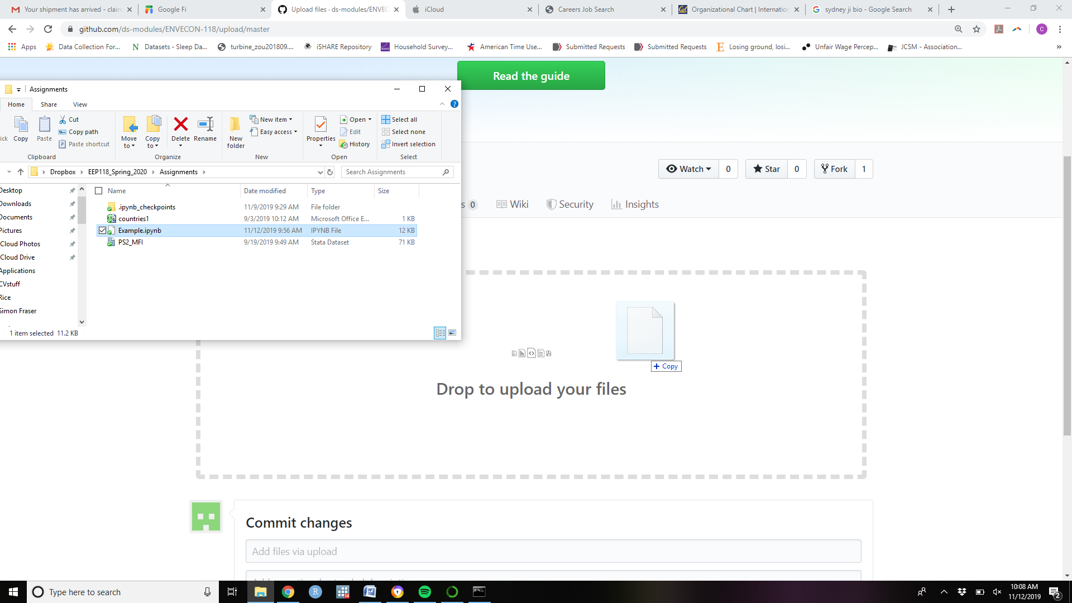

1. and click Commit changes at the bottom.

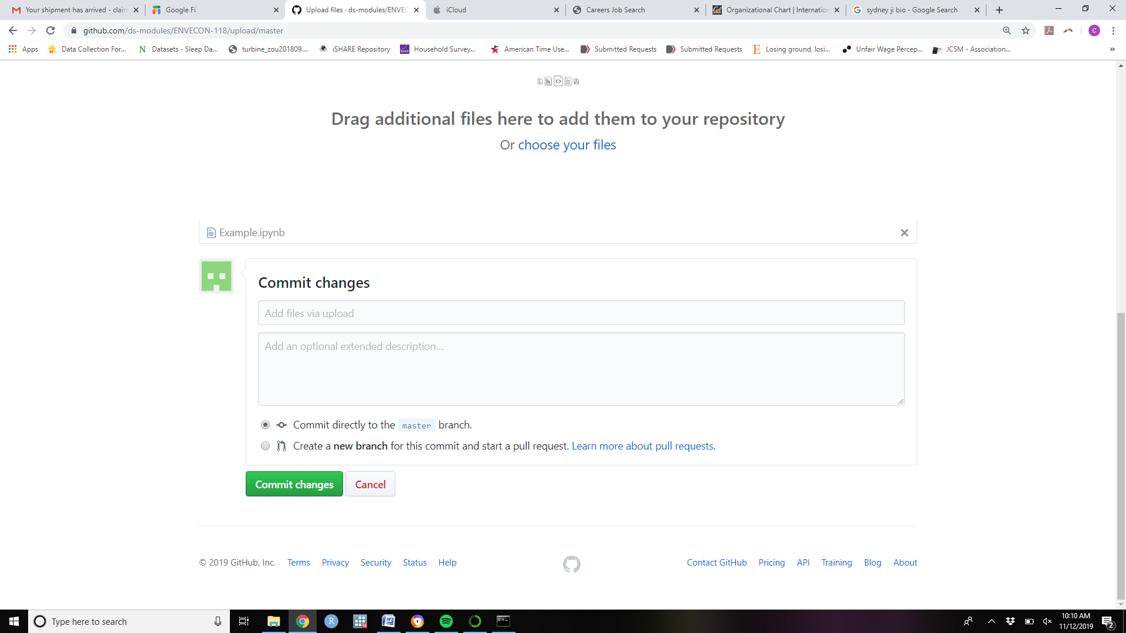

The file (Example.ipynb) now appears in the github folder

Putting the file in a folder:

1. Click on the file. The workbook will now appear in github

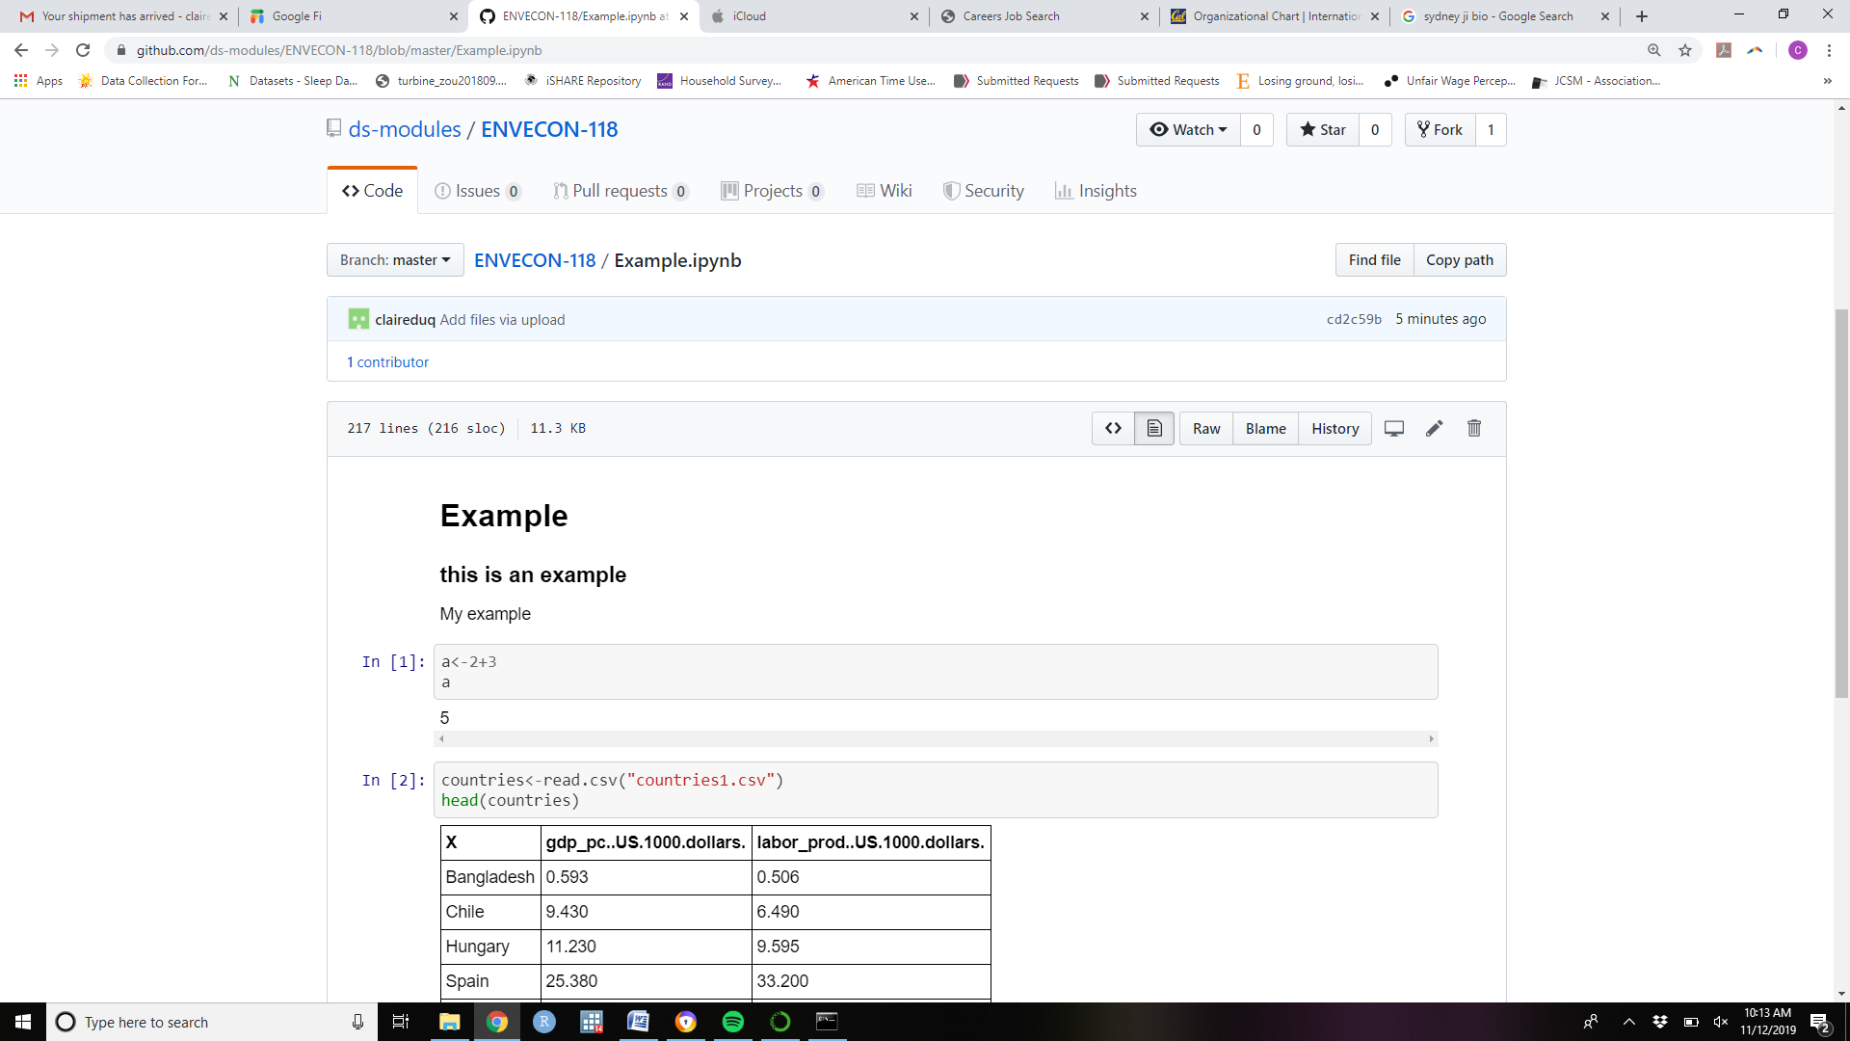

1. Click on the little pencil icon on the top right of the file

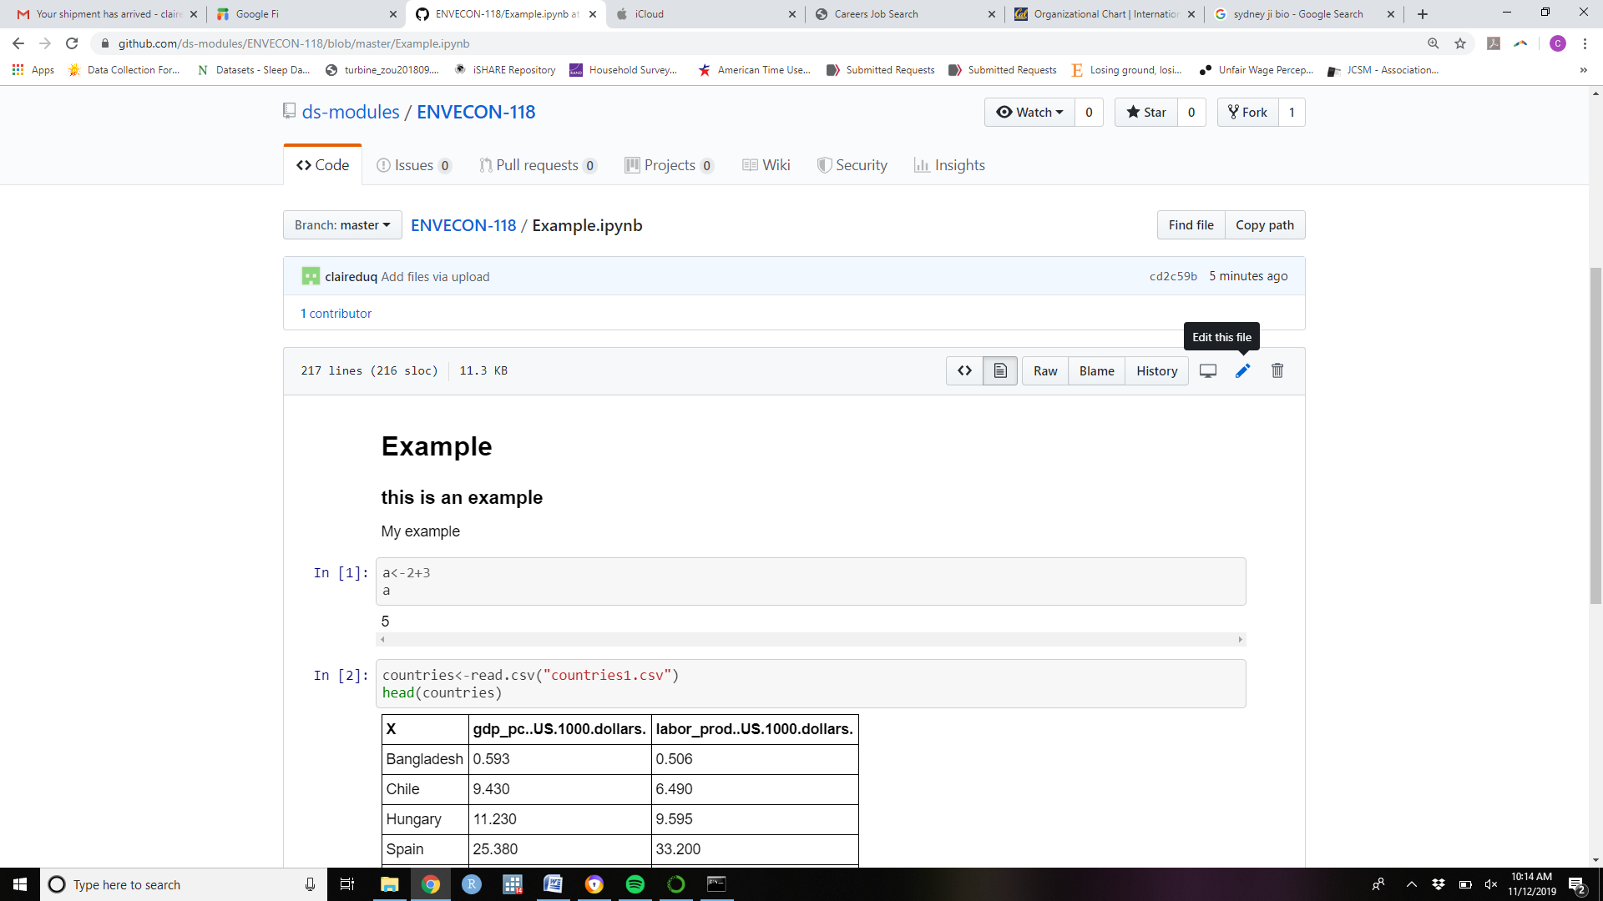

1. An editing box now appears around the file name.

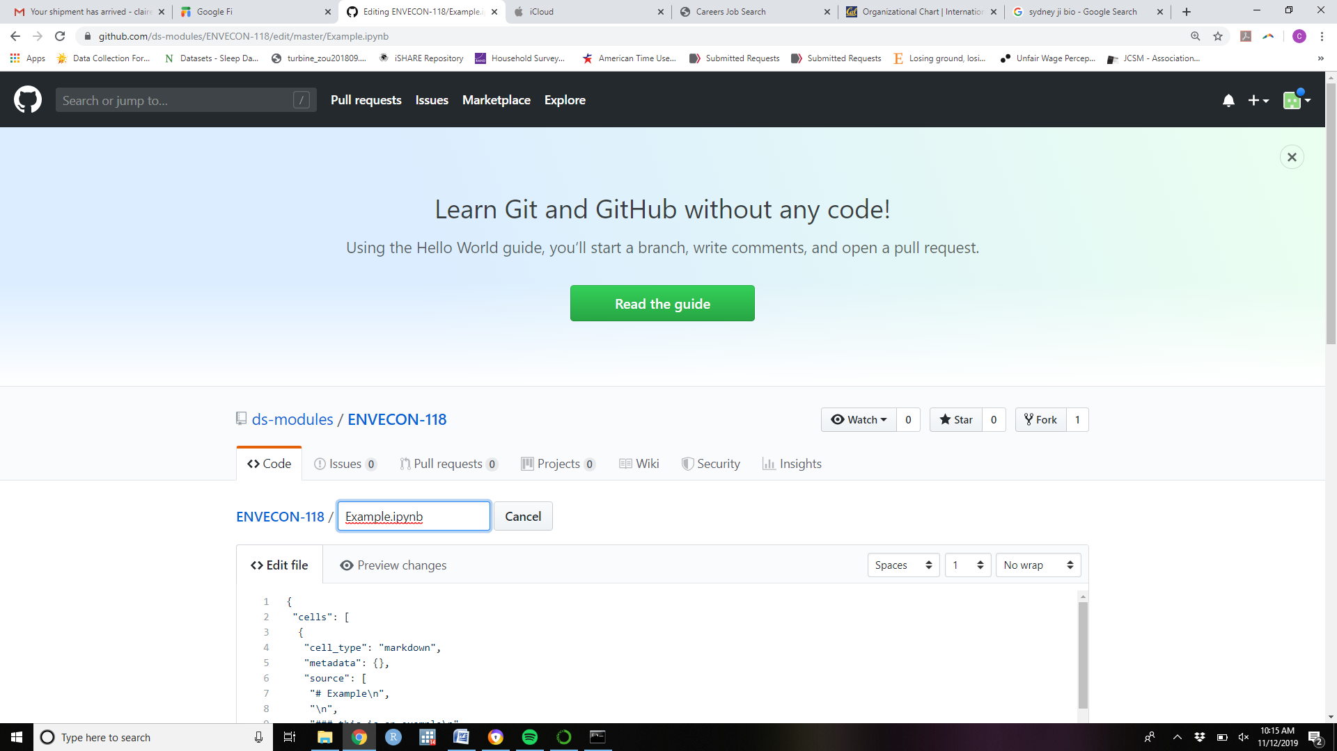

1. Type the name of the folder you wish to create followed by / before the file name. This will place the file in the newly created folder.

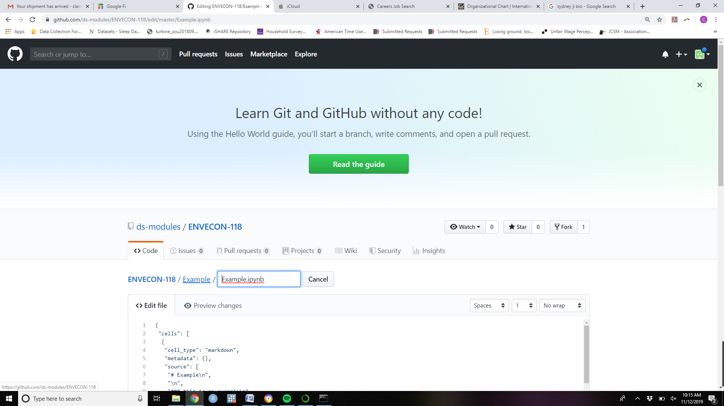

1. Click commit changes

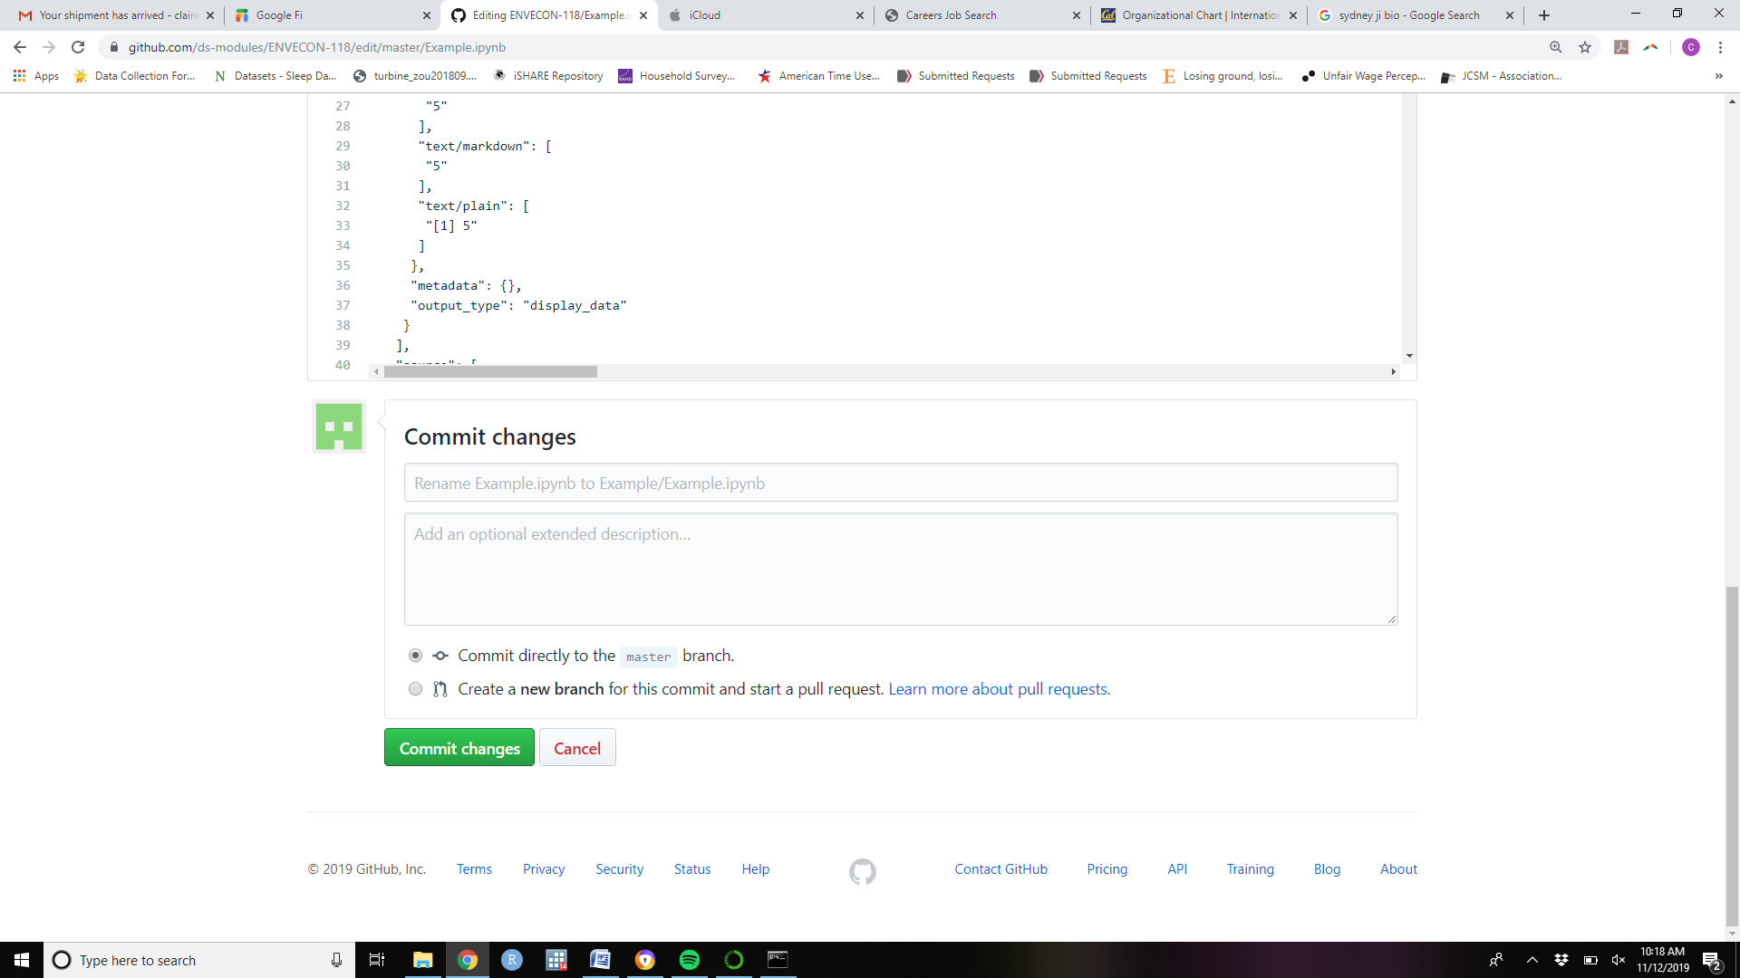

1. The new “Example” file you just created will appear in the github files

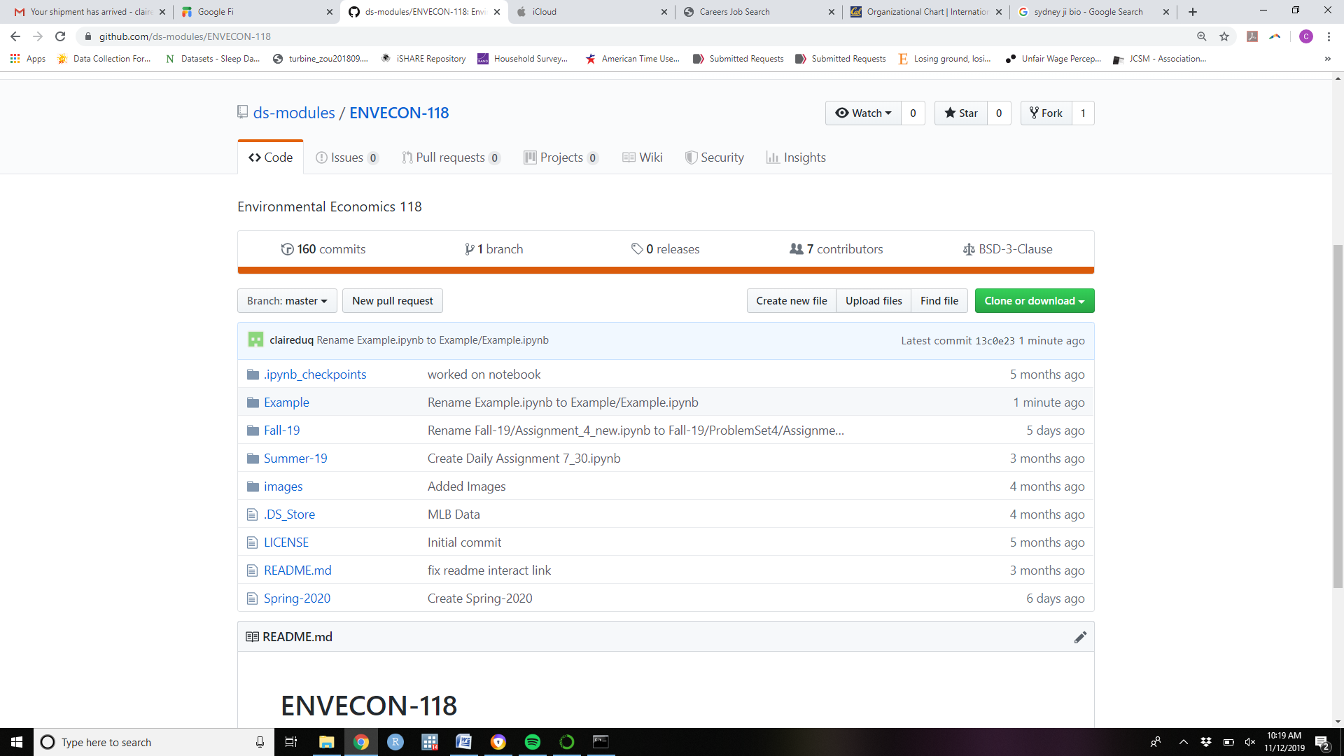

1. Upload the datasets into the “Example folder” so that they are available for students using the notebook

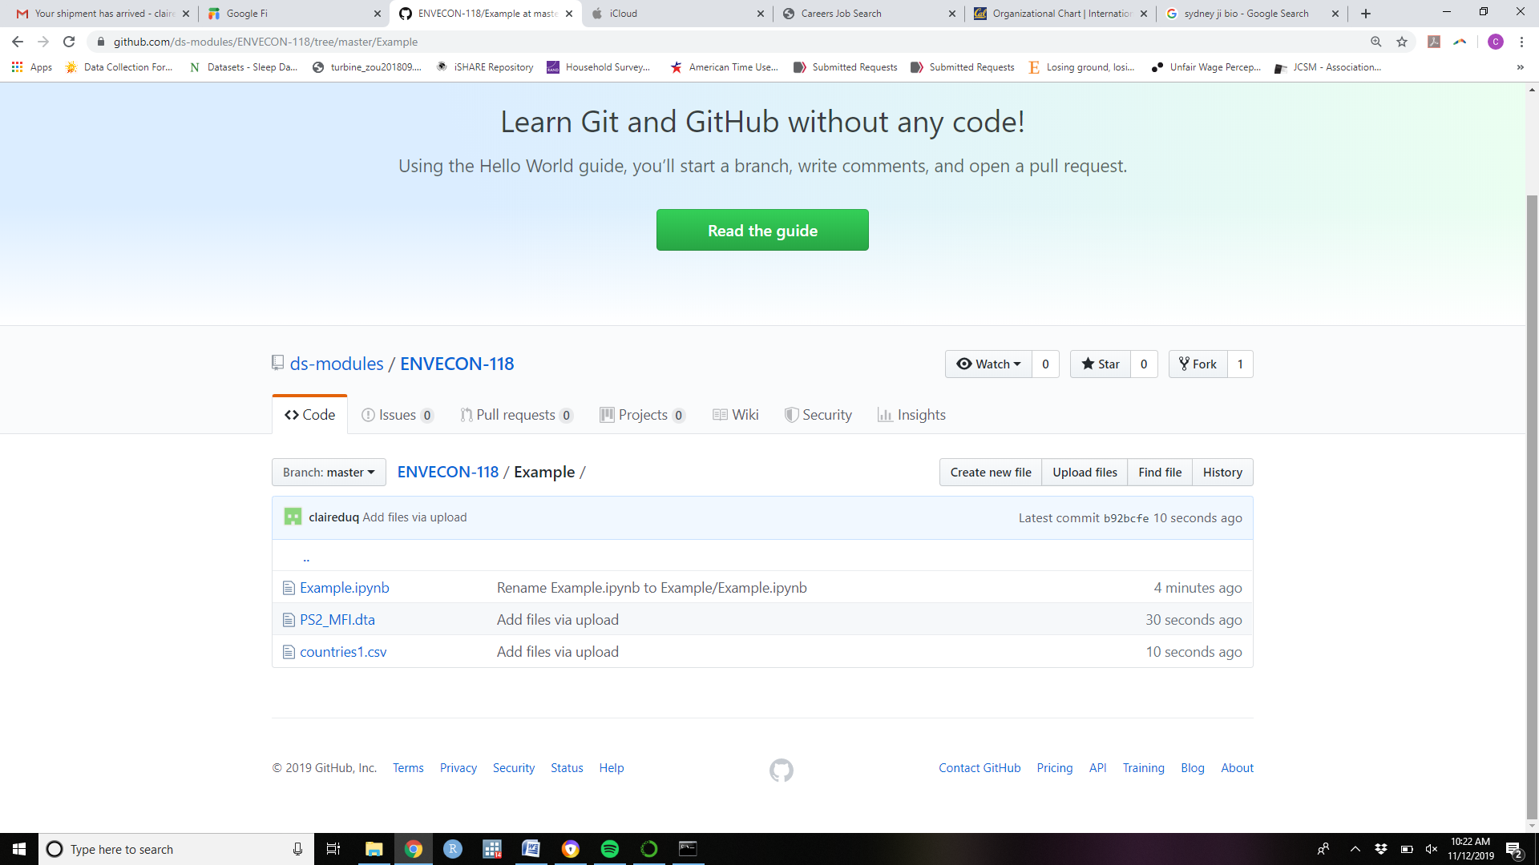

1. These files are now available on the internet.

NOTE: These files are now “findable” by crafty tech savy people. Don’t load solution keys here until problem sets are handed in if you don’t want anyone seeing them ahead of time.

Making a Jupyter Notebook accessible to students:

We need to create a link that will lead students to the notebook we created. To do this go to the following website: <https://jupyterhub.github.io/nbgitpuller/link>

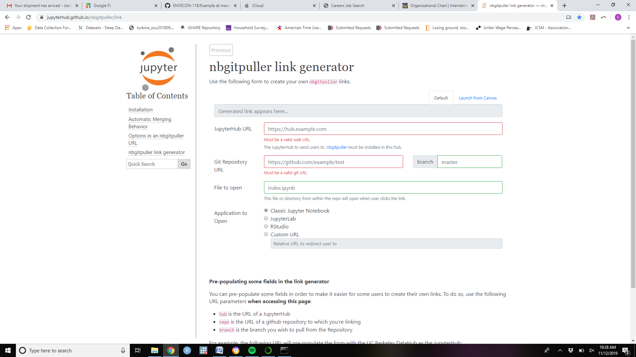

Fill out the form as follows:

1. For JupyterHub URL, copy in: https://datahub.berkeley.edu/
2. For GitReposetory URL:

Open the file you want to share in github and copy the first parts of the URL up to and including ENVECON-118

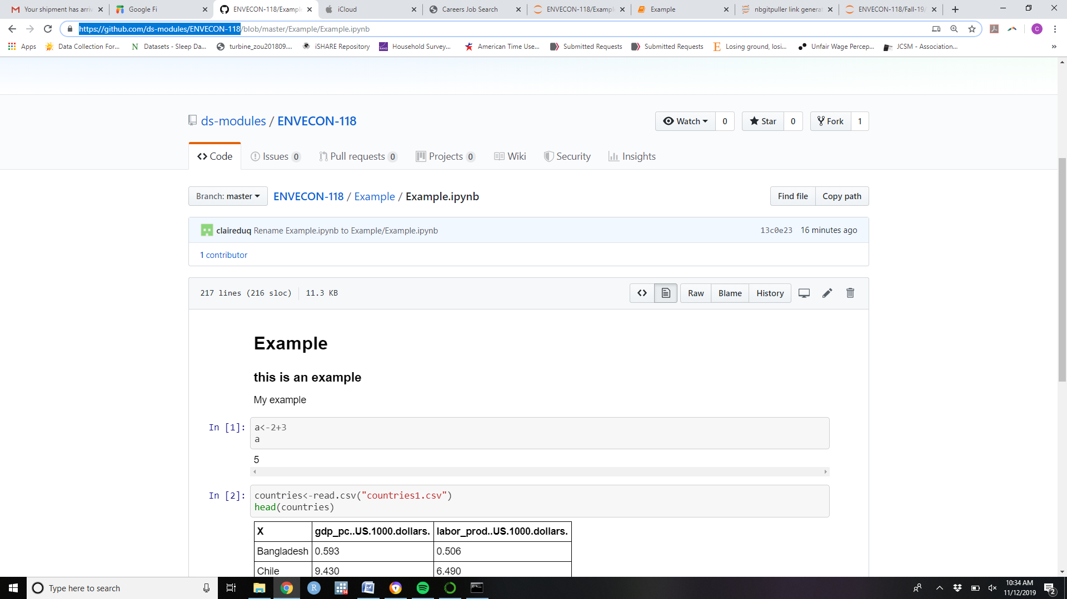

1. For file to open, copy the last part of the URL after master/

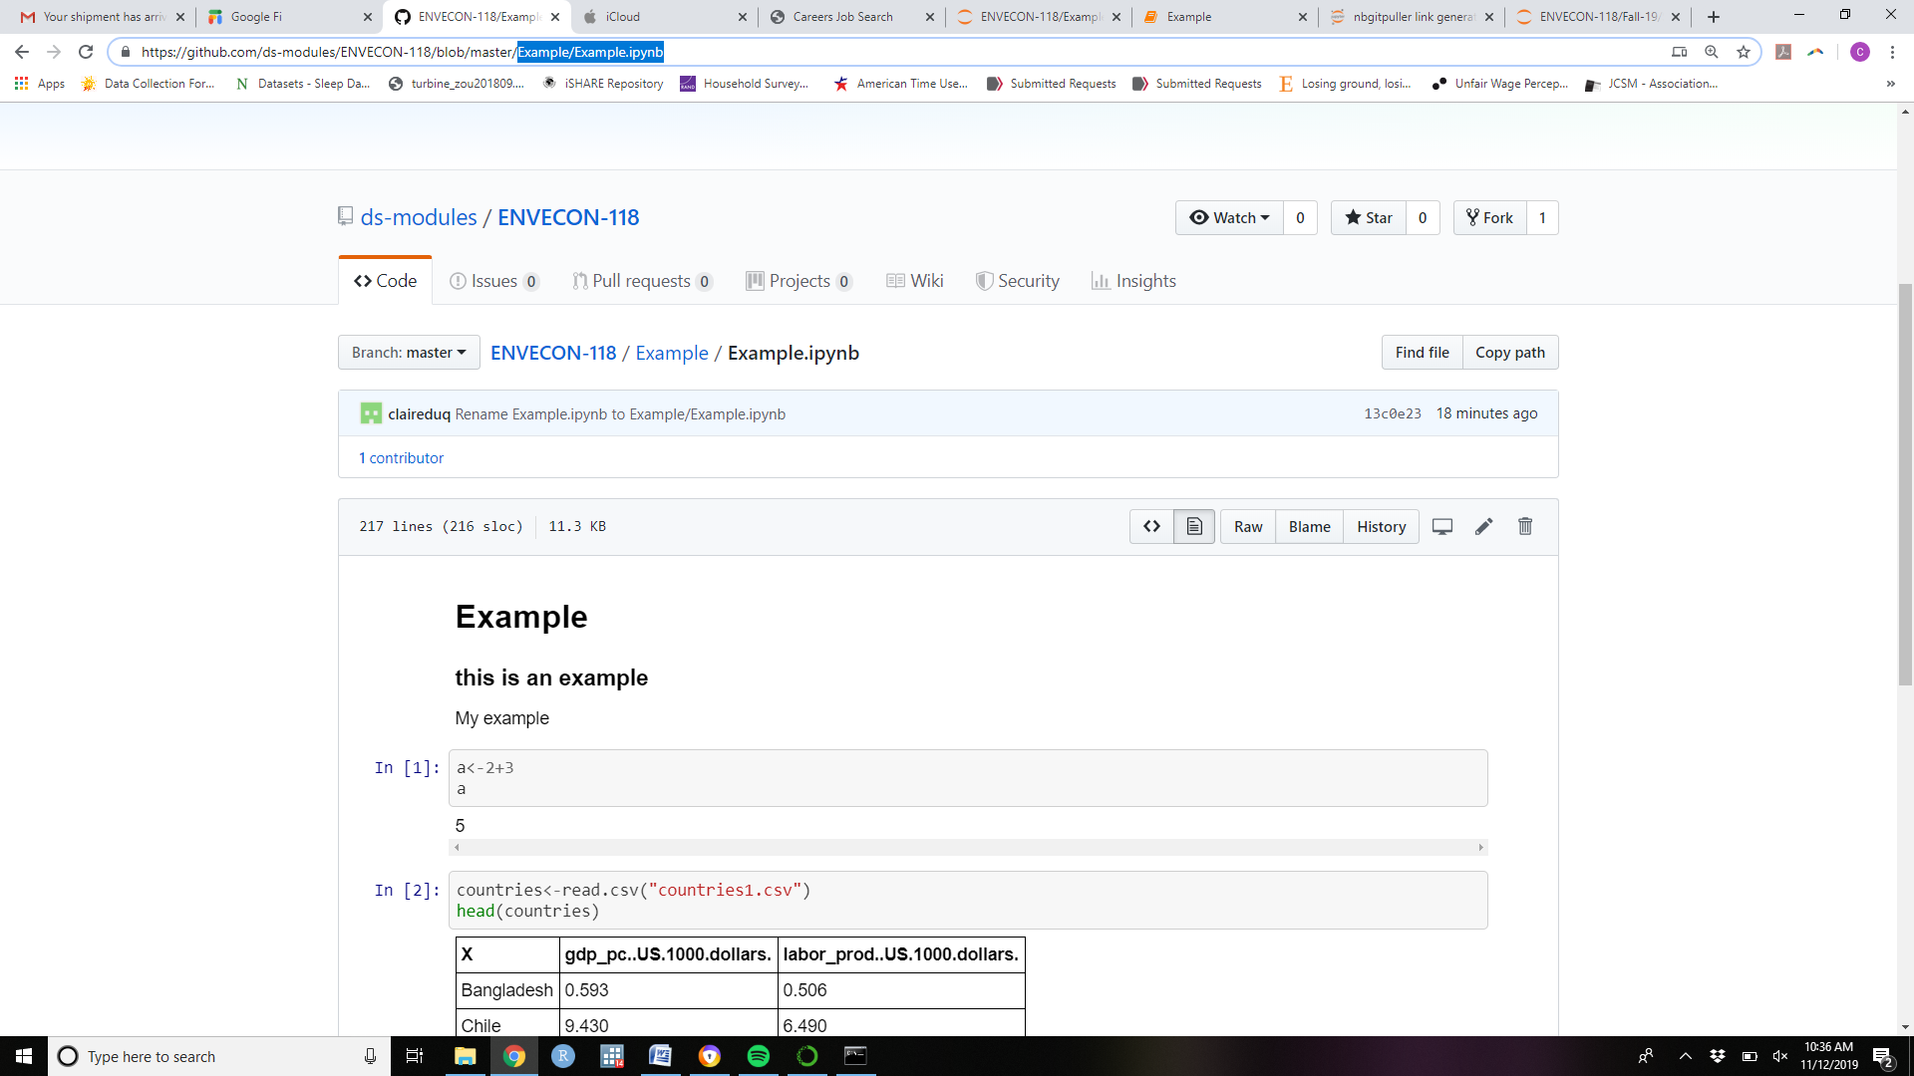

1. Once all the elements have been copied into the link generator, the hyperlink that will lead students to the notebook is generated in the shaded grey bar. Copy this link and paste it in a word document or announcement.

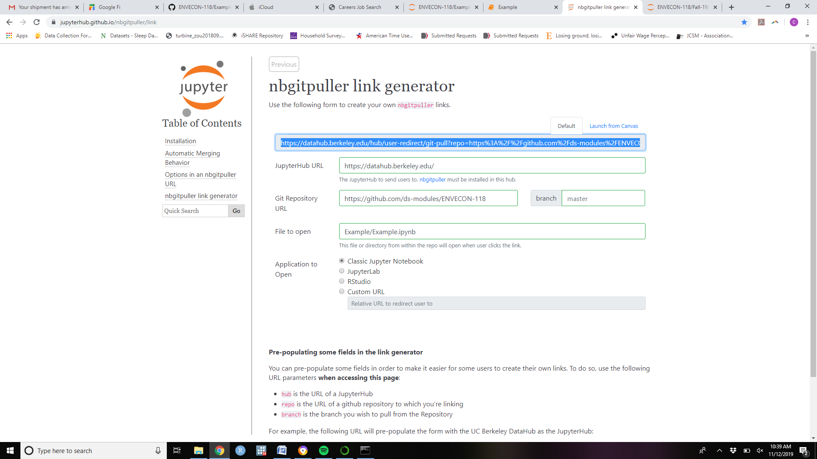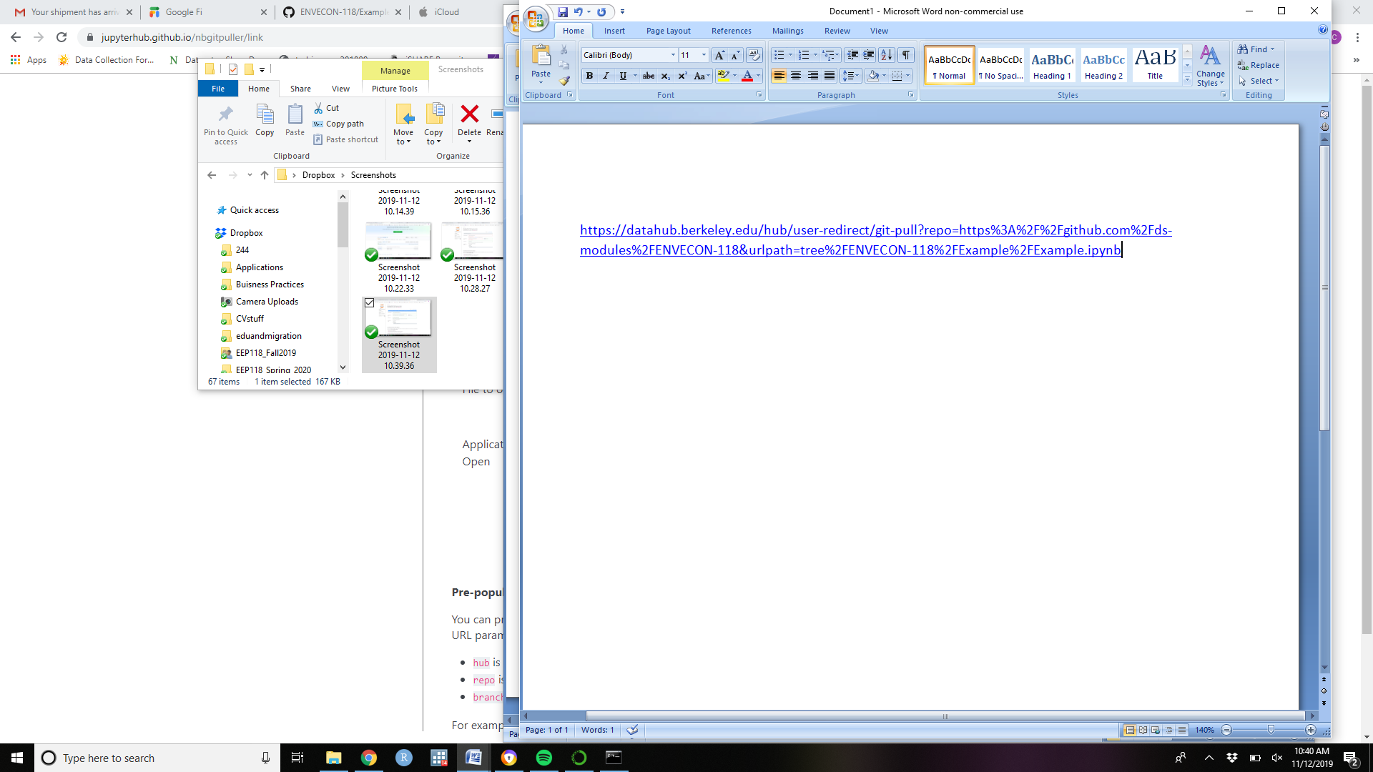

Share this hyperlink with the students. They can click on it and it will lead them to their own version of the notebook on the server which they can work on.

For Homework Assignments:

Students can work on the notebook. Changes are saved automatically.

For submissions:

Once they are done with the notebook and satisfied with their answers, they can selecyt File>> Download as>> PDFvia Chrome to download their entire notebook as a PDF (they should use PDFviaChrome no matter what browser they are using.

This PDF can be submitted to gradescope.

